FINAL YEAR INDUSTRIAL TRAINING
(Jan-June 2026)
Mid- Term Progress Report

This report, in the form of a template, has been specifically designed for B.E (C.S.E) students attending Industrial Training during 8th semester at respective Organizations/Industry/R&D Institutes.

Every student is required to do the following:
- Complete all the sections of this template
- Get it certified by your Industry Supervisor/HR Manager.
- Submit 01 hardcopy to the assigned faculty member on or before the day of evaluation:
- Email PDF/MS Word document at link shared in group.

Note:
- Use UK English
- There should be NO grammatical or spelling mistakes
- Submission after due date will not be accepted
- For more information, contact TPC (CSE).

- Read the above carefully and attach this page at the end of your report before submission -

Project identification
Name of Student (Roll No.) | Harsh Rana (uem223119)
Name of Organization/ Industry/R&D Institute | incedo inc.
Project title | bookstore application
Name of Technical Supervisor(s)/ Manager(s)  (As officially assigned at industry) | Supervisor:  Name: Anil Choppari  Designation: Senior Technical Lead(Banking)  Supervisor (if any):  Name:  Designation:  Supervisor (if any):  Name:  Designation:

CERTIFICATE
“This is to certify that the Industrial Training work until mid-year evaluation held on ___________________, titled as stated in Sec. 1.3, executed (as till date) by the student group mentioned in Sec. 1.1, has been found satisfactory and every section of this report is reflecting the same.” | (Signature of Supervisor & date)

Project insights
Thematic area(s) | Research S/W Development Industry Automation  Institute Automation  Other (please specify):  Sub-areas (optional):  Mobile Programming Web Programming HCI  Data Mining Networking Image Processing  Other (please specify):

Keywords
(Max. 3 to 6. Don’t use jargon or abbreviation)
Utilization scope | Domestic Commercial Industrial Scientific  Global National State District  GNDEC University External Sponsor  Other (please specify):
Major task(s)  (At least one should be checked) | Modeling S/W Designing Fabrication Testing  Validation Optimization Consultancy document  Physical tool(s) development Software development  Research & Development  Others (please specify):
Software packages, tools and programming languages  (Software piracy is strictly prohibited.) | MS Excel VBA C/C++/C# FORTRAN  MATLAB Maple Mathematica EES  AutoCAD Pro-E CATIA Adams  ANSYS Fluent CFX SPICE  TRNSYS HAP WindFarmer RETScreen  MiniTab SPSS SAS R / S  VB Java PHP ASP/.NET  Oracle SAP MySQL SQL  Mobile phone development (please specify):  Others (please specify):

Relevant study material
Undergrad. courses  (Must be from Information Technology/ Computer Science Engineering or other Applied Areas. Add more rows if required.) | Course code and title  1.  2.  3.  4.  5.  6.

Online / web resources  (Must be easily accessible. Search engines, social blogs, and unauthentic resources should not be mentioned. Any reliable URL shortening service may be used. Add more rows if required.) | URL of specific web page  1. GitHub Link: Harshrana2022/Bookstore_Application_Final: Full stack application built using spring boot and react.  2.  3.  4.

Objective / Scope
The objective of the BookStore Application (The Book Nook) project is to develop a comprehensive, scalable e-commerce platform that revolutionizes the online book retail experience. The project aims to bridge the gap between modern software architecture practices and user-centric e-commerce solutions, providing a seamless shopping experience for customers while empowering administrators with robust management and analytics tools.
The primary goal is to create a complete end-to-end solution that demonstrates professional software engineering practices including proper separation of concerns, secure authentication mechanisms, and data integrity management. The Book Nook is designed to be production-ready, with extensibility built into its foundation to accommodate future features such as advanced payment integrations, recommendation engines, and expanded analytics capabilities.

Project Scope

The project encompasses the following key dimensions:

- Backend Infrastructure Development: Design and develop a microservices-based backend architecture consisting of six independent, loosely-coupled services that communicate through well-defined RESTful APIs. Each microservice is responsible for a specific business domain, allowing for independent development, testing, deployment, and scaling. The Service Registry provides dynamic service discovery, eliminating the need for hardcoded service endpoints and enabling seamless horizontal scaling.

- Frontend Application Development: Implement a modern, responsive React-based user interface built with TypeScript support, ensuring type safety and improved developer experience. The frontend is structured to provide two distinct interfaces—one for end-users engaging in book shopping activities and another for administrators managing inventory, users, and business metrics. Both interfaces prioritize user experience through responsive design that adapts seamlessly across desktop, tablet, and mobile devices while maintaining accessibility compliance with WCAG 2.1 standards.

- Security Implementation: Establish a secure, stateless authentication system using JWT (JSON Web Tokens) with BCrypt password hashing, eliminating server-side session storage requirements and enabling scalable distributed deployments. Role-based access control distinguishes between USER and ADMIN roles at both API and frontend levels, ensuring that sensitive operations are properly protected and user data remains secure throughout the system.

- Book Catalog and Inventory Management: Develop a comprehensive book catalog system supporting detailed product information including title, author, ISBN, category, pricing, stock quantities, and discount management. The system enables administrators to perform complete CRUD operations on the inventory, ensuring that the catalog remains current and accurate while providing customers with comprehensive search and filtering capabilities to discover desired books efficiently.

- Shopping and Payment Processing: Implement a secure shopping cart system allowing customers to accumulate multiple books for purchase, with real-time price calculations considering applicable discounts. The order management system handles complex order structures supporting multiple items per order while maintaining referential integrity. The payment service provides transaction processing, status tracking, and audit logging for compliance and troubleshooting purposes.

- Admin Analytics Dashboard: Create a business intelligence dashboard that provides administrators with comprehensive insights into business performance through real-time metrics, revenue tracking, sales analysis, customer management, and payment monitoring. The dashboard features animated counters and visual representations of key performance indicators enabling data-driven decision making.

- Containerization and Deployment: Package each microservice and the frontend application as Docker containers with optimized configurations, enabling consistent deployment across development, staging, and production environments. This approach eliminates "works on my machine" problems and facilitates rapid deployment pipelines and horizontal scaling.

- Service Discovery and API Gateway Patterns: Implement the Service Registry pattern using Netflix Eureka to provide dynamic service discovery, and the API Gateway pattern using Spring Cloud Gateway to serve as a single entry point for all client requests. These patterns abstract away the complexity of managing multiple microservice endpoints and enable advanced features like cross-origin resource sharing configuration and request routing.

The scope deliberately focuses on delivering a complete, functional e-commerce platform rather than addressing every possible feature. However, the architecture is designed with extensibility as a core principle, allowing for future enhancements such as advanced search capabilities, machine learning-based recommendations, multiple payment providers, and expanded reporting features without requiring architectural redesign.

Expected outputs
The project delivers discrete, tangible outputs that collectively form a complete, production-ready e-commerce platform. These outputs represent both the technical artifacts created during development and the functional capabilities delivered to end-users and administrators.

- Backend Micro-services Suite: Six fully functional Spring Boot micro-services are delivered, each providing specialized functionality through well-designed RESTful APIs. The Service Registry enables dynamic service discovery and health monitoring. The API Gateway serves as the unified entry point for all client requests, implementing CORS policies, request routing, and protocol translation. The User Service provides authentication, registration, and user management capabilities with JWT-based stateless authentication. The Order Service manages the complete order lifecycle including order creation, retrieval, and cancellation with proper cascade operations. The Payment Service handles transaction processing, status tracking, and audit logging. Each service is independently deployable and scalable, allowing for optimization based on specific load requirements.

- Comprehensive Frontend Application: A fully functional React application featuring two distinct user interfaces—a customer-facing shopping portal and an administrative dashboard. The customer portal includes home page with book catalog, user authentication pages, shopping cart interface, checkout process, order history tracking, and payment status confirmation. The admin portal includes comprehensive dashboard with business metrics, user management interface, book inventory management system, and payment analytics. All interfaces are responsive, accessible, and provide intuitive navigation with proper error handling and user feedback through toast notifications.



- Secure Authentication System: A complete JWT-based authentication mechanism integrated with Spring Security at the backend, providing secure user registration, login, and session management. BCrypt password hashing with configurable strength ensures that passwords are securely encrypted even in the event of database compromise. The system implements role-based access control at both API and frontend levels, ensuring that sensitive operations are restricted to appropriate user roles. JWT tokens include expiration mechanisms and signature verification to prevent token tampering.

- REST API Documentation: Comprehensive documentation of all API endpoints including HTTP methods, URL paths, request/response schemas, authentication requirements, and error responses. The documentation provides sufficient detail for frontend developers to integrate with backend services and for potential third-party integrations in the future. Each endpoint is documented with example requests and responses, required headers, and possible error conditions.

- Business Intelligence Dashboard: A comprehensive admin dashboard providing real-time insights into business performance through animated counter displays of key metrics, revenue charts, sales trend analysis, customer management views, and payment status distribution. The dashboard integrates with the backend services to provide accurate, real-time data while maintaining responsive performance even under high data volumes.

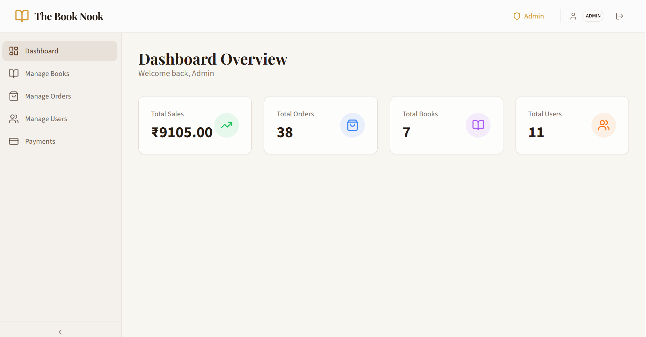

- Complete Shopping Portal: A fully functional e-commerce interface enabling customers to discover books through browsing, advanced search, and category filtering, add items to a shopping cart with quantity management, proceed through a checkout process with order review, and track orders after purchase. The portal includes user authentication, profile management, and order history with detailed order information.
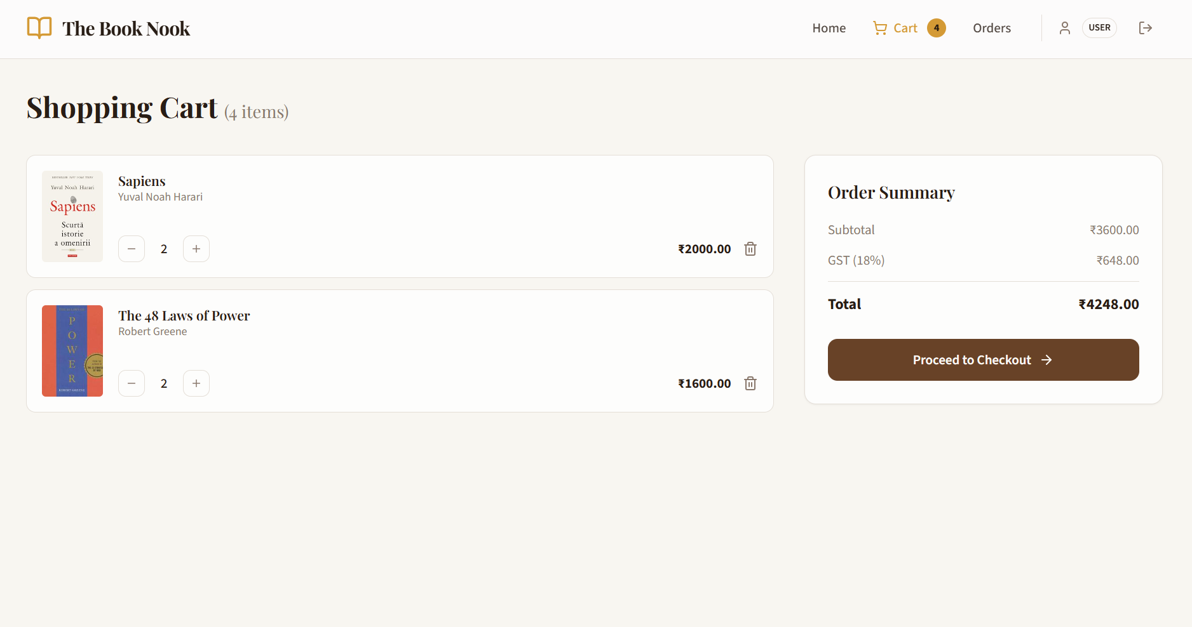

- Transaction Management System: A comprehensive payment processing system that creates payment records, tracks transaction status through multiple states (PENDING, COMPLETED, FAILED), integrates with payment providers through transaction IDs, and maintains complete audit logs for compliance and troubleshooting. The system prevents payment processing errors through proper validation and provides administrators with complete visibility into payment status and transaction history.

- Deployment and Operational Guides: Complete documentation for building, testing, deploying, and operating the application including Docker build instructions, deployment procedures for various environments, configuration management guidance, and troubleshooting resources. This enables operations teams to deploy and maintain the application with minimal friction.

Utilization
The Book Nook platform serves multiple distinct beneficiary groups, each deriving specific value from the application based on their unique roles and requirements.

- End-User Customers: Individual readers, students, and book enthusiasts represent the primary customer base for The Book Nook platform. These users benefit from a convenient, accessible online channel for discovering and purchasing books without the constraints of geographic location or store hours. The advanced search functionality enables customers to quickly find books by title, author, or genre, while filtering capabilities help users navigate the extensive catalog efficiently. The shopping cart functionality allows customers to compare multiple books before committing to a purchase, and the order history tracking provides visibility into past purchases, enabling customers to reorder favorite titles or continue abandoned shopping sessions. This segment derives value from convenience, selection, and user experience.

- Book Retailers and Independent Publishers: Small to medium-sized book retailers and independent publishers can leverage The Book Nook platform to expand their market reach beyond geographic limitations. For retailers without extensive technical infrastructure, the platform provides a turnkey e-commerce solution avoiding the need to develop systems from scratch. Independent publishers can use the platform to sell directly to customers without intermediaries, improving profit margins. Publishers and retailers benefit from the inventory management capabilities, allowing them to manage stock levels efficiently and monitor sales performance. The analytics dashboard provides visibility into sales trends and customer behavior, enabling data-driven inventory decisions.

- Platform Administrators and Store Managers: Store managers and administrators require comprehensive tools for daily operations. The admin portal provides these stakeholders with user management capabilities to handle customer accounts, role assignments, and account deactivations as needed. Inventory management tools enable administrators to add new books, modify pricing and discount structures, track stock levels, and retire out-of-print titles. The payment management interface provides visibility into all transactions, enabling reconciliation and anomaly detection. Administrators benefit from time savings through streamlined operations and improved visibility into business activities.


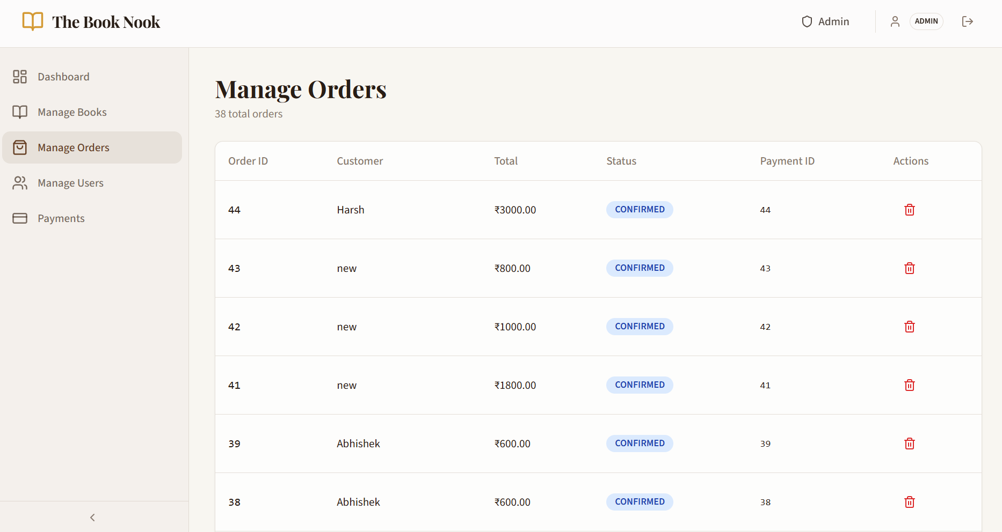

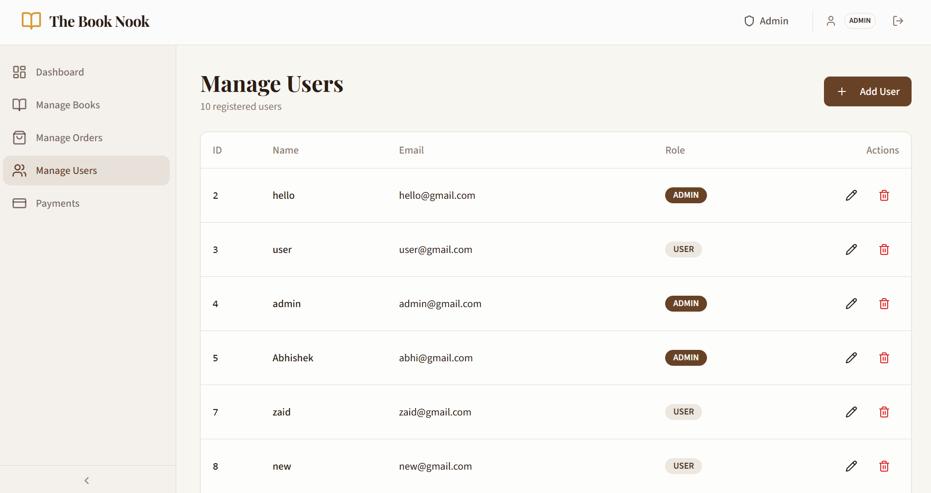

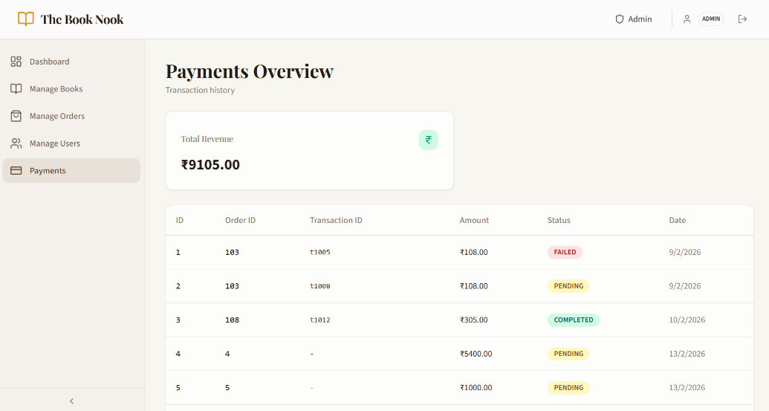

- Software Engineers and Maintainers: The technical team responsible for operating and maintaining the platform benefits from the clear microservices architecture, comprehensive documentation, and modern technology choices. The microservices design enables engineers to understand, modify, and deploy individual components without impacting others. The use of industry-standard frameworks and libraries facilitates onboarding of new team members. The containerization approach simplifies deployment and enables continuous integration/continuous deployment (CI/CD) pipelines.

Target Market

The platform targets the online book commerce industry, a sector experiencing sustained growth as consumer preferences shift toward digital-first shopping experiences. The addressable market includes both emerging e-commerce markets seeking cost-effective solutions and established retailers seeking platform modernization. The platform is particularly suited for independent bookstores seeking digital transformation, educational institutions managing book sales and inventory, publishing companies expanding distribution channels, B2C e-commerce retailers in the books and media sector, and niche communities with specialized reading interests such as technical books, academic texts, or independent literature.

The competitive advantages of The Book Nook include its modern, scalable architecture enabling growth without architectural redesign, comprehensive feature set covering the complete e-commerce lifecycle, responsive design providing excellent user experience across devices, and open extensibility enabling customization for specific market segments. The microservices architecture allows enterprises to scale individual components based on demand, while the professional security implementation meets requirements for systems handling financial transactions.

Literature study / Data collection
The project development was informed by comprehensive study of contemporary software architecture patterns, e-commerce best practices, and modern web technologies. This literature study provided the theoretical foundation and practical guidance that shaped every architectural decision and implementation choice in The Book Nook platform.

- Microservices Architecture Foundations: The development team studied foundational works on microservices design patterns including Sam Newman's "Building Microservices: Designing Fine-Grained Systems," which provided comprehensive guidance on service decomposition strategies, inter-service communication mechanisms, and distributed system challenges. Newman's work emphasizes the importance of clear service boundaries and independent deployment capabilities, principles that directly influenced the design of The Book Nook's six service architecture. Additional research focused on microservices trade-offs, including the increased operational complexity offset by improved scalability and development velocity. Industry standards from the Spring Cloud documentation and Spring Boot best practices provided implementation guidance specific to the Java ecosystem. The team evaluated alternative architectural approaches including monolithic architectures and service-oriented architectures, concluding that microservices best served the project's requirements for independent scalability and team autonomy.

- Service Discovery and API Gateway Patterns: Research into service discovery mechanisms revealed the Netflix Eureka pattern as a proven approach used by large-scale systems handling millions of requests daily. The team studied how Eureka manages dynamic service registration and deregistration, enabling services to discover each other without hardcoded endpoints. The API Gateway pattern research, informed by Kong, AWS API Gateway, and Spring Cloud Gateway documentation, led to the selection of Spring Cloud Gateway as the unified entry point for all requests. This pattern provides centralized management of cross-cutting concerns including authentication, logging, rate limiting, and CORS configuration. The study revealed that API gateways, while introducing an additional network hop, provide significant operational benefits through centralized policy enforcement and simplified client integration.

- Database Design and Normalization Theory: The project team conducted thorough research into relational database design principles, studying normalization theory through Codd's foundational work and modern interpretations in books like "Database Design and Relational Theory" by C.J. Date. The team studied ACID (Atomicity, Consistency, Isolation, Durability) properties essential for financial transactions and the specific implications for payment processing. Research into MySQL's transaction handling and InnoDB engine capabilities informed decisions about transaction isolation levels and locking mechanisms. The team evaluated normalization levels, concluding that Third Normal Form (3NF) provided the appropriate balance between query simplicity and data redundancy. Specific research into foreign key constraint handling, cascade operations, and referential integrity enforcement ensured proper implementation in the order and payment systems where data consistency is critical.

- Security, Authentication, and Cryptography: The security implementation was grounded in extensive research into modern authentication mechanisms. Study of RFC 7519 (JSON Web Tokens) provided the technical specification for JWT implementation. The team researched password hashing algorithms, comparing bcrypt, scrypt, and PBKDF2, ultimately selecting bcrypt for its proven security properties and built-in salt generation. Research into OAuth 2.0 and OpenID Connect provided context for understanding JWT's role in the broader authentication landscape. The team studied OWASP (Open Web Application Security Project) guidelines for secure API design, including recommendations for authentication headers, CORS policies, and common vulnerability prevention. Research into HTTPS/TLS ensured proper understanding of transport-layer security requirements.

- E-Commerce Platform Design and Best Practices: The team analyzed established e-commerce platforms including Shopify, WooCommerce, and Magento to understand proven design patterns for shopping carts, checkout processes, and inventory management. Research into payment gateway integrations revealed common patterns for handling various payment methods while maintaining security and PCI compliance. The team studied conversion rate optimization research revealing that page performance, clear pricing, and streamlined checkout processes significantly impact purchase completion rates. Research into inventory management systems revealed approaches for handling stock depletion, backorders, and inventory synchronization across channels. Case studies of successful e-commerce platforms provided insights into scalability challenges and architectural approaches.

- Modern React Development and Component Architecture: The project team conducted comprehensive research into React 18 and 19 development patterns, studying the evolution from class components to functional components with hooks. Research into React's virtual DOM and reconciliation algorithm informed component design decisions. The team studied React Hook patterns from the React documentation and community resources, evaluating best practices for useState, useEffect, useContext, and custom hooks. Research into Context API for state management included evaluation of alternative solutions like Redux and Recoil, with Context API selected for the project's requirements. The team studied TypeScript integration with React, including proper typing of components, hooks, and props. Research into component composition patterns and the "compound components" pattern informed the overall component hierarchy design.

- Responsive Design and Web Accessibility: The project incorporated comprehensive research into responsive design principles from sources including "Responsive Web Design" by Ethan Marcotte and CSS Tricks articles. The team studied CSS Grid and Flexbox in depth, including modern layout techniques for creating responsive interfaces without media query bloat. Research into accessibility standards included detailed study of WCAG 2.1 guidelines, particularly guidelines for keyboard navigation, screen reader compatibility, and color contrast requirements. The team evaluated Radix UI's accessibility-first component approach, which provides unstyled, accessible components following WAI-ARIA practices. Research into accessibility testing tools and techniques enabled the team to validate that the implementation met stated accessibility objectives.

- Data Collection: Beyond literature review, the project team conducted practical data collection through analysis of existing e-commerce applications, studying user interaction patterns during e-commerce transactions, and consulting with technical advisors regarding current best practices and emerging technologies. Analysis of user behavior data from established e-commerce platforms revealed common patterns in shopping behavior, search preferences, and checkout completion rates. The team collected information about payment provider integrations and common approaches to handling payment processing. Performance benchmarking data from Spring Boot and React community reports, including performance comparison studies and load testing results, informed technology selection decisions and architectural trade-off evaluations.

Methodology
S. No. | List of Training/Project milestones | Deliverable(s) | Expected number of days to complete | Percent Completed
1. | Planning and System Design | Outline of the project, integration strategy of microservices and database design. | 4 | 12%
2. | Creating Microservices using Springboot | Developed the project backend using Java Springboot microservices architecture. | 10 | 40%
3. | Creating Frontend using React | Developed the project frontend using React. | 5 | 60%
4. | Integrating frontend with backend | Connecting backend APIs with frontend. | 2 | 90%
5. | Dockerization and deployement on AWS | Containerized each microservice and the frontend to deploy it on AWS. | 2 | 100%

Executed work
The Book Nook project has been successfully developed through systematic implementation following a structured development lifecycle emphasizing clean architecture, comprehensive testing, and production-readiness. The following section provides detailed documentation of completed work, achieved results, and delivered components.

9.1 Backend Infrastructure Development

Service Registry Implementation: The Service Registry component serves as the central nervous system of The Book Nook's microservices architecture. Implemented using Spring Cloud Netflix Eureka, this component maintains a continuously updated registry of all available microservices, their network locations, and health status. The implementation includes automatic service registration when microservices start up, automatic deregistration when services stop, and periodic health checks every 30 seconds to verify service availability. The registry uses client-side load balancing, where the API Gateway queries Eureka to discover service instances and distributes requests across multiple instances when available.

The Eureka server dashboard provides operators with real-time visibility into service health, displaying which services are registered, how many instances exist for each service, and the current status of each instance. This visibility enables rapid identification of service failures and facilitates understanding of system state during operational issues. The implementation supports service filtering by name and status, enabling targeted investigation of problems. The registry includes configurable timeout thresholds, allowing adjustment of how quickly failed services are removed from the registry based on operational requirements.

Key Deliverables:
- Eureka server configuration with automatic service registration
- Health check endpoints for service monitoring
- Service instance lookup mechanism
- Support for dynamic service registration and deregistration
Result: A robust service discovery infrastructure enabling dynamic microservice communication without hardcoded service endpoints.

API Gateway Development: The API Gateway, implemented using Spring Cloud Gateway with a reactive WebFlux backend, serves as the single entry point for all client requests from the React frontend. This strategic architectural decision centralizes request handling, enabling uniform application of cross-cutting concerns and eliminating the need for clients to discover individual service locations. The gateway implements sophisticated routing rules that examine incoming requests and forward them to appropriate backend services based on URL path patterns.

The CORS (Cross-Origin Resource Sharing) implementation explicitly allows requests from the React frontend running at http://localhost:3000, enabling frontend-to-backend communication across origins. The configuration specifies allowed HTTP methods (GET, POST, PUT, DELETE, PATCH, OPTIONS), permitted headers (all headers including Content-Type and Authorization), and support for credentials including cookies. This configuration balances security (restricting to known origins) with functionality (allowing necessary methods and headers).

The gateway's reactive architecture processes requests asynchronously without blocking, enabling efficient handling of high request volumes and multiple concurrent connections. The WebFlux implementation uses Project Reactor underneath, providing powerful stream processing capabilities and backpressure handling. The gateway dynamically discovers backend services through Eureka integration, automatically adapting to services coming online or going offline without requiring gateway configuration changes or restarts.

Implemented Features:
- CORS configuration allowing requests from http://localhost:3000
- Dynamic routing to microservices using Eureka service discovery
- Request/response filtering and modification capabilities
- Support for HTTP methods: GET, POST, PUT, DELETE, PATCH, OPTIONS
- Credentials support for session management
Result: A production-ready API gateway enabling seamless frontend-to-microservice communication with proper cross-origin resource sharing.

9.2 User Service Implementation

User Authentication System: The User Service implements a comprehensive authentication and authorization system enabling secure user registration, login, and session management. The registration endpoint accepts user details including name, email, password, and role assignment, validating inputs against constraints ensuring data quality. Email uniqueness is enforced at the database level through unique constraints, preventing account duplication. Passwords undergo multiple transformation steps: first, Spring Security validators ensure passwords meet minimum length requirements (6 characters minimum); second, BCryptPasswordEncoder hashes passwords with configurable strength (default 12 rounds), generating a unique salt for each password; third, only the hashed password is persisted to the database.

The login endpoint validates supplied credentials by retrieving the user record by email and comparing the supplied password against the stored hash using BCrypt's timing-safe comparison function, preventing timing-based attacks. Upon successful authentication, the JwtUtil component generates a JWT token containing the user's email and role, signed with the application's secret key. This token is returned to the client, where it is stored and included in subsequent API requests, enabling stateless authentication without server-side session storage.

Authentication Endpoints:
- POST /api/users/auth/register: Accepts user registration with email validation and password encryption
- POST /api/users/auth/login: Validates credentials and returns JWT token valid for session

User Management Endpoints:
- GET /api/users: Retrieves list of all registered users (admin-only)
- GET /api/users/{id}: Fetches specific user details with validation
- PATCH /api/users/{id}: Updates user information with authorization checks
- DELETE /api/users/{id}: Removes user account with cascade operations

Security Implementation:
- BCryptPasswordEncoder for password hashing with configurable strength (12 rounds)
- JwtUtil for token generation and validation using JJWT library v0.11.5
- Spring Security configuration for endpoint protection
- Role-based access control distinguishing between USER and ADMIN roles

User Management Capabilities: Beyond authentication, the User Service provides complete user management functionality. The list users endpoint enables administrators to retrieve all registered users with their details, supporting user discovery and management. The get user endpoint retrieves a specific user's profile including name, email, and role, enabling users to view their own profiles and administrators to inspect user details. The update user endpoint allows administrators to modify user information including name, email, and role assignment, with proper authorization checks ensuring that regular users cannot modify other users' accounts. The implementation includes special handling for password updates, only overwriting passwords when explicitly provided, allowing updates to other fields without disturbing existing credentials. The delete user endpoint enables account removal, with proper cascade handling of related data.

Role-Based Access Control: The User Service implements two distinct roles—USER for regular customers and ADMIN for administrative staff. The role is persisted in the user record and included in JWT tokens, enabling both backend services and frontend components to make authorization decisions based on role. The implementation follows the principle of least privilege, restricting sensitive operations to the ADMIN role. User endpoints include authorization annotations preventing non-admin users from accessing sensitive operations, while allowing users to access their own profile information.

9.3 Order Service Implementation

Complex Order Structure: The Order Service manages the complete order lifecycle, handling orders containing multiple books with quantity tracking and price management. The underlying data model uses two related tables: the Orders table storing order-level information including user ID (linking to the customer), payment ID (linking to the associated payment), and total price (computed from order items); the OrderItems table storing individual items within each order, including book ID, quantity, and the unit price at the time of order (enabling historical price tracking even if catalog prices change).

The one-to-many relationship between Orders and OrderItems, with cascade delete operations, ensures that deleting an order automatically removes all associated order items, maintaining referential integrity without orphaned records. The implementation includes proper transaction handling, ensuring that either an entire order with all its items is created, or nothing is created, preventing partial order creation due to transient failures.

Order Lifecycle Management: The order creation endpoint accepts a complete order request including user ID, list of order items with book IDs and quantities, and enables comprehensive validation before order creation. The implementation calculates the total price from item-level prices and quantities, enabling verification that the client-side calculation matches server-side calculation. Upon successful creation, the order is persisted with an initial status and a timestamp indicating creation time.

The order retrieval endpoints enable users to view their order history with pagination support, allowing efficient navigation through orders even for customers with extensive purchase history. Each order includes the associated items with details enabling customers to understand what they purchased and for what price. The get order by ID endpoint returns complete order details suitable for display on an order confirmation or tracking page. The delete order endpoint enables order cancellation with business logic determining whether cancellation is permitted (e.g., preventing cancellation of orders already shipped or paid).

Implemented Endpoints:
- POST /api/orders/user-only: Creates order with items and calculates total price
- GET /api/orders/user-only: Retrieves user's complete order history with pagination
- GET /api/orders/user-only/{id}: Fetches detailed order information with items
- DELETE /api/orders/user-only/{id}: Cancels order with validation checks
Result: A fully functional order management system with support for multi-item orders, order history tracking, and cascade operations maintaining referential integrity.

9.4 Payment Service Implementation

Transaction Processing and Tracking: The Payment Service manages payment processing with comprehensive tracking of payment status through multiple states. Each payment record includes the associated order ID, payment amount, status (PENDING, COMPLETED, or FAILED), transaction ID for external payment provider integration, and timestamps indicating creation and last modification time. The automatic timestamp tracking enables understanding of when payments were initiated and when status changes occurred, crucial for debugging and compliance.

The payment creation endpoint initializes payment records with PENDING status, enabling the order confirmation flow to progress even before actual payment processing completes. The status query endpoints enable customers and administrators to check payment status at any time, with filtering by multiple criteria (payment ID, order ID, status, transaction ID) enabling comprehensive payment investigation. The update endpoint enables status transitions, typically changing PENDING payments to COMPLETED when the payment provider confirms successful processing, or to FAILED when payment declined or failed.

Audit and Compliance: The implementation includes comprehensive audit capabilities through automatic timestamp tracking, enabling understanding of payment history and duration in each state. The transaction ID field enables correlation between The Book Nook's payment records and external payment provider systems, crucial for debugging failed payments and handling disputes. The immutable creation timestamp, combined with mutable updated timestamp, creates an audit trail showing when status changes occurred. This audit trail proves invaluable during payment investigations, chargebacks, or regulatory audits.

9.5 Frontend Application Development

Dual-Interface Architecture: The frontend implements two entirely separate user interfaces serving different audiences with different requirements. The customer-facing shopping portal includes the home page displaying book catalog with search and filtering, login and registration pages for authentication, shopping cart interface enabling product selection and quantity management, checkout page for order review and confirmation, order history page showing past purchases, and order summary page showing detailed order information.

The admin portal includes a comprehensive dashboard displaying key business metrics including total revenue, transaction count, best-selling books, and customer acquisition metrics; user management interface showing registered users with administrative controls; book inventory management system enabling complete CRUD operations on the catalog; and payment analytics showing transaction history, status distribution, and revenue trends. The separation of these interfaces prevents regular users from accidentally accessing administrative features while allowing administrators convenient access to management tools.

Component Architecture and Reusability: The frontend uses React's component-based architecture to achieve high reusability and maintainability. Radix UI provides foundational building blocks—accessible, unstyled components implementing WAI-ARIA best practices. Shadcn/ui builds on Radix UI to provide pre-styled, composable components. The development team created custom components wrapping these primitives to provide application-specific functionality. The book card component, for example, displays book information with images, pricing, and add-to-cart functionality, reused throughout the application whenever books are displayed.

The shopping cart component manages cart state, enabling users to add items, modify quantities, remove items, and proceed to checkout. The product filters component displays available filter options (by category, price range, availability) with interactive controls. Protected route components prevent unauthorized access to sensitive areas like order history and checkout pages. The implementation uses React Router for navigation, providing efficient page transitions and browser history support.

State Management: The frontend employs React Context API for global state management, centralizing management of authentication state (current user, JWT token), shopping cart state (items, quantities, total price), and UI state (active filters, sort preferences). Custom hooks encapsulate complex state logic and enable reuse across components. The useAuth hook manages authentication, including login, registration, logout, and token persistence. The useCart hook manages shopping cart operations including adding items, updating quantities, and calculating totals. The useFilter hook manages filter state and provides functions for filter updates.

9.6 Database Schema and Deployment

Schema Implementation: The MySQL database implements a carefully designed schema following normalization principles to ensure data integrity and query efficiency. The Users table stores user account information with proper constraints preventing invalid data. The Orders table maintains order records with foreign keys to Users and Payments tables. The OrderItems junction table enables one-to-many relationships between orders and items, with foreign keys back to Orders and references to Books. The Payments table tracks payment records with unique constraints preventing duplicate payments and enum types enforcing valid status values.

Indexes on frequently queried columns (user_id, order_id, payment_id) enable efficient query execution even with large datasets. Cascade delete operations ensure that deleting an order automatically removes associated order items, preventing orphaned records that would waste storage and complicate queries. The implementation includes check constraints ensuring that monetary amounts are positive values and that only valid enum values appear in status columns.

Docker Containerization: Each component of the application is packaged as a Docker container with optimized configurations. The backend services use multi-stage builds where dependencies are downloaded in one stage and the compiled application is copied into a minimal final image, reducing image sizes from potentially hundreds of megabytes to tens of megabytes. The Dockerfile for each service includes health check configurations enabling Docker to periodically execute a command (typically an HTTP health check endpoint) to verify service availability. Services failing health checks can be automatically restarted or removed from load balancers.

The frontend Dockerfile uses a multi-stage build, compiling the React application in one stage and copying the compiled static files to an Nginx server in the final stage. This approach enables serving the React application with proper HTTP caching headers and gzip compression, improving load times for end users. The Nginx configuration includes proper MIME type configuration for various file types and enables gzip compression for text resources.

Production Readiness: All containers include proper logging configuration, writing application logs to stdout/stderr rather than files, enabling Docker's logging infrastructure to capture and archive logs. Environment variables enable configuration without rebuilding containers, allowing the same image to be deployed across development, staging, and production environments with appropriate configuration. Security scanning tools can analyze images for known vulnerabilities before deployment, and secrets management systems can securely inject sensitive values like database passwords and JWT signing keys at runtime.

API ENDPOINTS SPECIFICATION

User Service API

9.7.1 Authentication Endpoints
- POST /api/users/auth/register - Register new user
- POST /api/users/auth/login - Authenticate user

User Management Endpoints
- GET /api/users - List all users
- GET /api/users/{id} - Get user details
- PATCH /api/users/{id} - Update user info
- DELETE /api/users/{id} - Delete user account

Order Service API
- POST /api/orders/user-only - Create new order
- GET /api/orders/user-only - List user's orders
- GET /api/orders/user-only/{id} - Get order details
- DELETE /api/orders/user-only/{id} - Cancel order

Payment Service API
- POST /api/payment - Create payment record
- GET /api/payment/admin-only - Get all payments
- GET /api/payment/admin-only/id/{id} - Get by payment ID
- GET /api/payment/admin-only/orderid/{orderId} - Get by order ID
- GET /api/payment/admin-only/status/{status} - Filter by status
- PATCH /api/payment/{id} - Update payment status

Domain Knowledge Training
From 18 February to 3 March, domain training sessions were conducted to introduce interns to the banking and financial services industry.

Retail Lending
Retail lending refers to financial institutions providing loans to individual customers.
Common products include:
- Personal loans
- Credit cards
- Mortgages
- Lines of credit
Banks evaluate borrowers based on credit score, income, debt-to-income ratio, and repayment history to determine loan approval and interest rates.

Personal Loans and Line of Credit
A personal loan is typically an unsecured loan repaid in fixed installments over a specified time period.A line of credit provides a pre-approved borrowing limit that allows customers to withdraw funds as needed.

Credit Cards and Mortgages
Credit cards allow customers to borrow money up to a predefined credit limit and repay it later.
Mortgages are secured loans used to purchase property, where the property itself acts as collateral.

Anti-Money Laundering (AML) and KYC
AML regulations help prevent illegal money from entering the financial system.
Financial institutions implement processes such as:
- Know Your Customer (KYC) to verify customer identity
- Customer Due Diligence (CDD) to monitor financial activities
These measures help detect suspicious transactions and prevent financial crimes.

Financial Risk Management
Financial institutions face different types of risks such as:
- Credit Risk – borrower fails to repay loan
- Operational Risk – failures in internal systems or processes
- Liquidity Risk – inability to meet short-term financial obligations
Banks use various monitoring and regulatory frameworks to manage these risks.

Payment Gateway Systems
A payment gateway enables businesses to accept digital payments securely.
It encrypts payment information and sends it to banks for authorization.
Payment gateways support:
- Credit cards
- Debit cards
- QR payments
- Mobile wallets

Financial Fraud
Financial fraud refers to deceptive practices used to gain financial benefits.
Examples include:
- Identity theft
- Credit card fraud
- Mortgage fraud
- Fake charity scams
Financial institutions use monitoring systems and regulations to detect and prevent fraud.

Work to be Done in Remaining Internship Period
During the remaining period of the internship, the focus will be on gaining deeper technical knowledge and applying the concepts learned so far through practical implementation and advanced training.
• Advanced Agentic AI development
Further learning and implementation of advanced concepts related to Agentic AI, including designing and developing autonomous AI agents for enterprise applications.
• Hands-on AI labs using AWS services
Participation in practical labs to gain experience with AWS AI and machine learning services and understand how AI solutions are implemented in cloud environments.
• Implementation of AI-powered enterprise applications
Working on building applications that integrate AI capabilities to automate tasks and support intelligent decision-making in enterprise systems.
• Further improvements to full-stack application projects
Enhancing existing full-stack projects by improving features, optimizing performance, and implementing additional functionalities.
• Learning advanced cloud and DevOps practices
Continuing to develop knowledge of cloud deployment, containerization, and DevOps tools to improve application development and deployment workflows.

Remaining work

References
- Java Official Documentation:
Java Documentation - Get Started
- Spring Boot Documentation:
Documentation Overview :: Spring Boot
- React Documentation:
Getting Started – React
- AWS Training and Certification Materials:
AWS (Amazon Web Services) Course
- Docker Documentation:
Docker Docs
- Incedo Training Resources:
Pages - Dashboard

Gantt chart
A detailed and neat Gantt chart should be attached separately after this page. Attached page may be landscape but it should not have any page number, header and footer. Gantt chart should be listing all the major and minor activities, indicating executed and remaining tasks, along with the time spans. Make sure that the Gantt chart is reflecting all the Training milestones as described in Sec 8-10.

Evaluation by Faculty Member(s)
Please if work is satisfactory or if work is not satisfactory and therefore requires a revision.
Section | Remarks by Faculty Member | Remarks by Faculty Member(s) (if any) | Remarks by Faculty Member(s) (if any)
1. Technical Knowledge/
Project Assigned

2. Project insights
3. Relevant study material
4. Objective/Scope
5. Expected outputs
6. Utilization
7. Literature study/Data collection
8. Methodology
9. Executed work
10. Remaining work
11. References
12. Gantt chart
Overall performance
Signature and date

- This page intentionally left blank -

